**Personal Development 2021**

# Roadmap

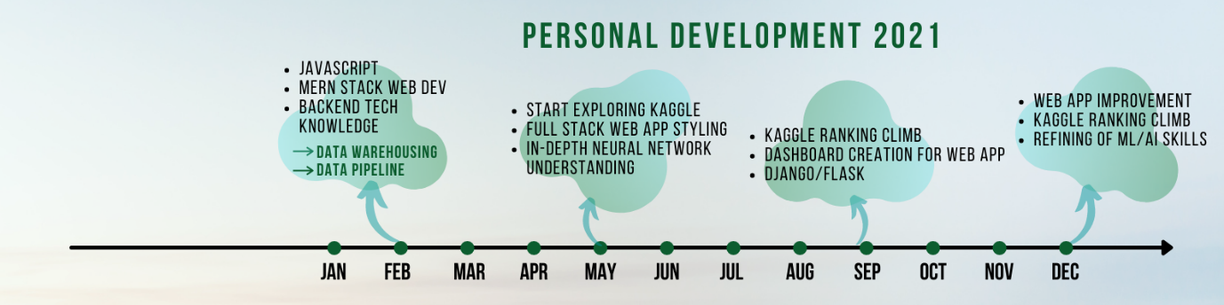

Priorities

1. ~~JavaScript~~
2. Kaggle / SQL
3. Systems Expert
4. Google certificate
   1. Project management (coursera)
   2. Deep Learning
   3. Data analyst
5. Geospatial data­­

<https://www.pola.com/wecaremore/>

NLP or computer vision?

<https://towardsdatascience.com/would-you-rather-be-an-nlp-or-computer-vision-data-scientist-5b1d45e1c601>

NLP

<https://github.com/mhagiwara/100-nlp-papers>

cross check with this website <https://paperswithcode.com/sota>

CV

<https://github.com/jbhuang0604/awesome-computer-vision>

Or read the mark peng Kaggle solution, compare AlexNet, ResNet etc

Courses to take

1. [Google Cloud Big Data & Machine Learning Fundamentals](https://google.qwiklabs.com/courses/1561?utm_source=gcp_training&utm_medium=website&utm_campaign=cgc) 
   1. Click on “Take this course on demand”
2. [Data Engineering on Google Cloud](https://google.qwiklabs.com/courses/1530?utm_source=gcp_training&utm_medium=website&utm_campaign=cgc)
3. [Preparing for the Google Cloud Professional Data Engineer Examination](https://google.qwiklabs.com/courses/1547?utm_source=gcp_training&utm_medium=website&utm_campaign=cgc)
4. [Google Project Management Professional Certificate](https://www.coursera.org/professional-certificates/google-project-management?utm_source=google&utm_medium=institutions&utm_campaign=gwgsite&_ga=2.92675869.1692013988.1617118043-558652120.1617118043#courses)

Personal Blogs topic

1. Environmental scientist into the tech industry – my journey into tech, and what’s next
2. How much data is in the environment?
3. ~~Spatial data analysis~~
4. ~~How I think about data~~
5. What three years of environmental science taught me about data
6. Curiosity in many subject areas, is it good or bad
7. What I’ve learned at my first job at a start-up
8. What do I think about the education system?
9. How can data/ML/Deep learning help solve various environmental issues
   1. How are people using ML and Deep learning to help the environment
   2. Find out the applications

How to start reading machine/deep learning papers

1. Check Kaggle for top solutions
2. Esp the multi model solution – mark peng

How to get started with deep learning

1. <https://www.kaggle.com/andradaolteanu/how-i-taught-myself-deep-learning-vanilla-nns>

# Overview

|  |  |
| --- | --- |
| **Month** | **Activity** |
| January | 1. Surge 2. ?? |
| February | 1. Surge (Herentals + Osmos) 2. JavaScript 3. Data Engineering (surface) |
| March | 1. Surge (Herentals) 2. JavaScript – start asynchronous material 3. Revise JavaScript 4. Data engineering – just read a little more daily. 5. Systems expert – start |
| April | 1. Surge |
| May | 1. Surge |
| June | 1. Surge |
| July | 1. Surge |
| August | 1. Surge |
| September | 1. Surge |
| October | 1. Surge |
| November |  |
| December |  |